**PIZZA SALES SQL QUERIES**

**A. KPI’s**

**1. Total Revenue: Write a Query to find the total Prize of all the orders?**

SELECT SUM(total_price) AS Total_Revenue FROM pizza_sales;

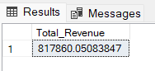

**2. Average Order Value: Write a Query to find the Average Order Value?**

SELECT (SUM(total_price) / COUNT(DISTINCT order_id)) AS Average_order_Value FROM pizza_sales

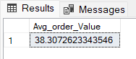

**3. Total Pizzas Sold: Write a Query to find the total Pizzas Sold?**

SELECT SUM(quantity) AS Total_pizza_sold FROM pizza_sales

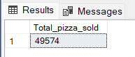

**4. Total Orders Placed: Write a Query to find the total orders placed?**

SELECT COUNT(DISTINCT order_id) AS Total_Orders FROM pizza_sales

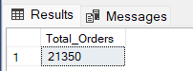

**5. Average Pizzas Per Order**

SELECT ROUND(SUM(quantity)/COUNT(DISTINCT order_id,2)

AS Avg_Pizzas_per_orderFROM pizza_sales

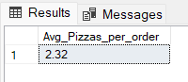

**B. Daily Trend for Total Orders**SELECT DAYNAME(STR_TO_DATE(order_date, '%Y-%m-%d')) AS Week_days, COUNT(DISTINCT order_id) AS total_orders

FROM pizza_sales

GROUP BY 1;

***Output:***

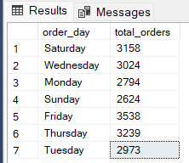

**C. Hourly Trend for Orders**

SELECT HOUR(order_time) as order_hours, COUNT(DISTINCT order_id) as total_orders

from pizza_sales

group by 1

order by desc 2;

***Output***

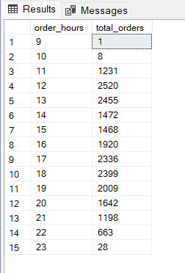

**D. % of Sales by Pizza Category**

SELECT pizza_category, ROUND(SUM(total_price),2) as total_sales,

ROUND(SUM(total_price) * 100 / (SELECT SUM(total_price) from pizza_sales),2) AS Total_Sales_Per_Category FROM pizza_sales

GROUP BY pizza_category

***Output***

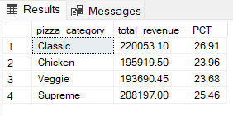

**E. % of Sales by Pizza Size**

SELECT pizza_size, ROUND(SUM(total_price),2) as total_SALES,

ROUND(SUM(total_price) * 100 / (SELECT SUM(total_price) from pizza_sales),2) AS Total_Sales_Per_Size

FROM pizza_sales

GROUP BY pizza_size

ORDER BY pizza_size;

***Output***

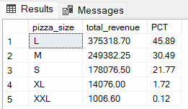

**F. Total Pizzas Sold by Pizza Category**

SELECT pizza_category, SUM(quantity) as Total_Quantity_Sold

FROM pizza_sales

WHERE MONTH(order_date) = 2

GROUP BY pizza_category

ORDER BY Total_Quantity_Sold DESC

***Output***

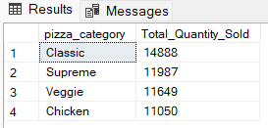

**G. Top 5 Best Sellers by Total Pizzas Sold**

SELECT Top 5 pizza_name, SUM(quantity) AS Total_Pizza_Sold

FROM pizza_sales

GROUP BY pizza_name

ORDER BY Total_Pizza_Sold DESC

***Output***

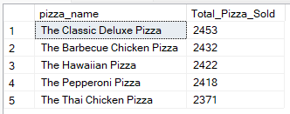

**H. Bottom 5 Best Sellers by Total Pizzas Sold**

SELECT TOP 5 pizza_name, SUM(quantity) AS Total_Pizza_Sold

FROM pizza_sales

GROUP BY pizza_name

ORDER BY Total_Pizza_Sold ASC

***Output***

